University of Wah
Department of Computer Science

Submit to:

Ms. Hassan Shafaqat

Submit by:

Muhammad Talha

Course:

Computer Network_Lab - CS-241L

Reg No:

UW-24-CS-BS-101

Section:

BS-CS-3rd-B

Question # 01:
Adding and connecting all PC , router, switches
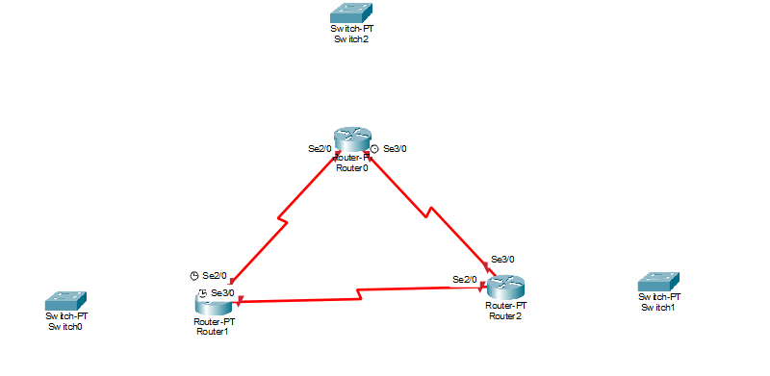
Connecting Everything in triangle form
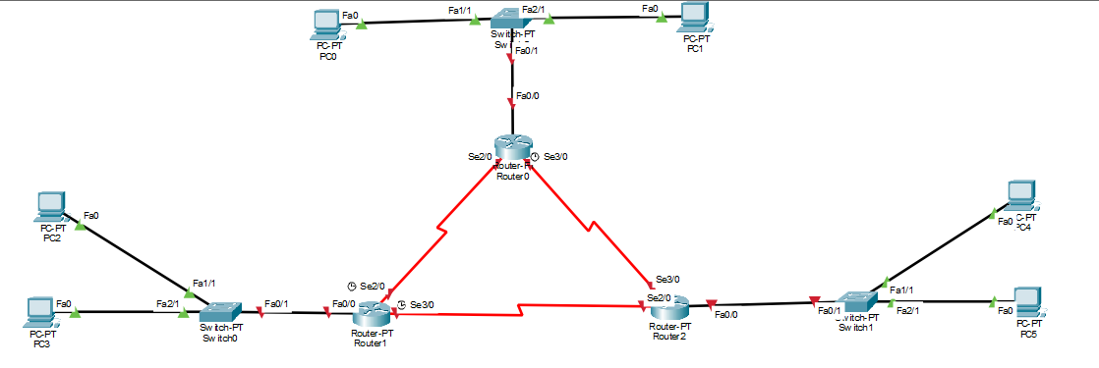
Giving IP address to PC
From (101)
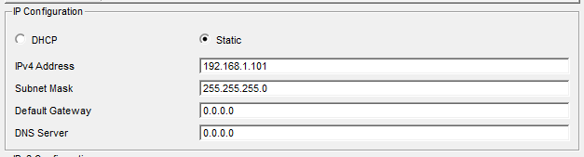
To (106)
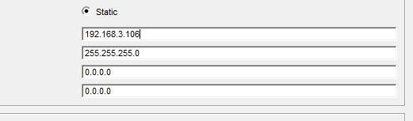
Giving Router IP address
Router 1
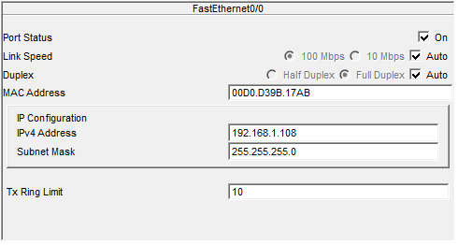
Router 2
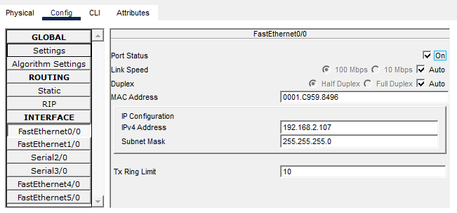
Router 3
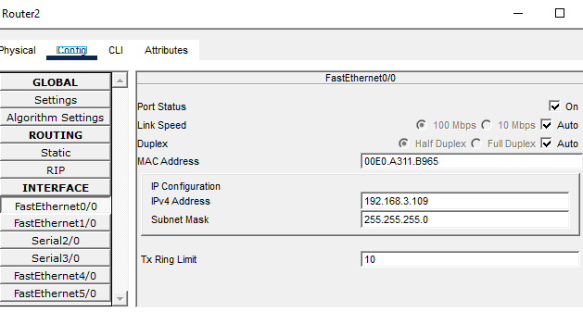
After All that
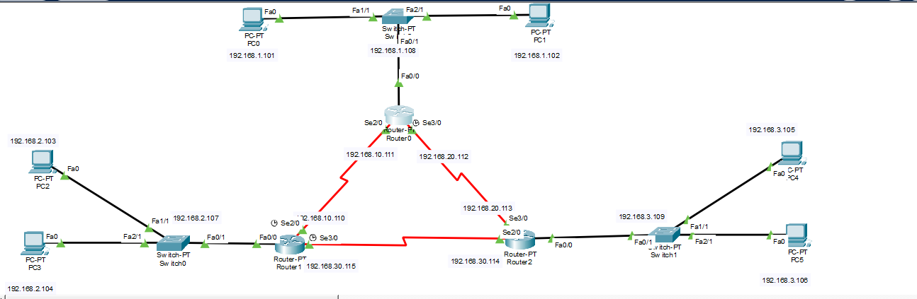
Applying Static Routing from static Option
Router 1:
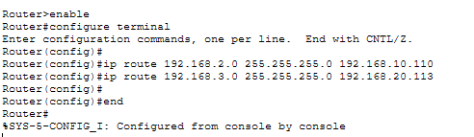
Router 2:
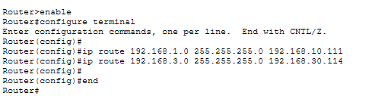
Router 3:
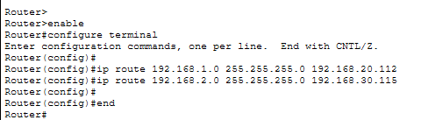

Sending Messages throught ping
From PC1(Router 1)
To PC3(Router 2)
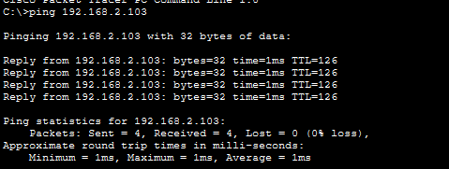
From PC1(Router 1)
To PC5(Router 3)
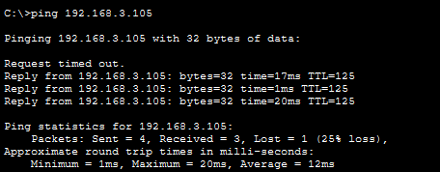
From PC2(Router 2)
To PC1(Router 1)
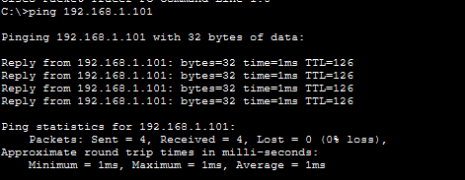
From PC1(Router 2)
To PC5(Router 3)
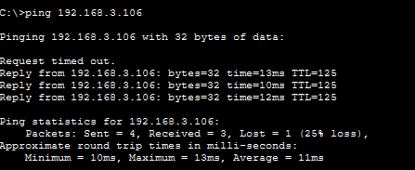
From PC2(Router 3)
To PC1(Router 1)
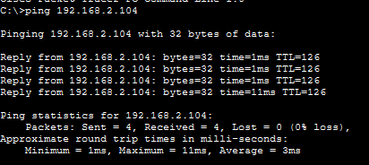

From PC1(Router 3)
To PC5(Router 2)

Question # 03
Adding 1 Router, 1 Switch, and 2 PCs in Network
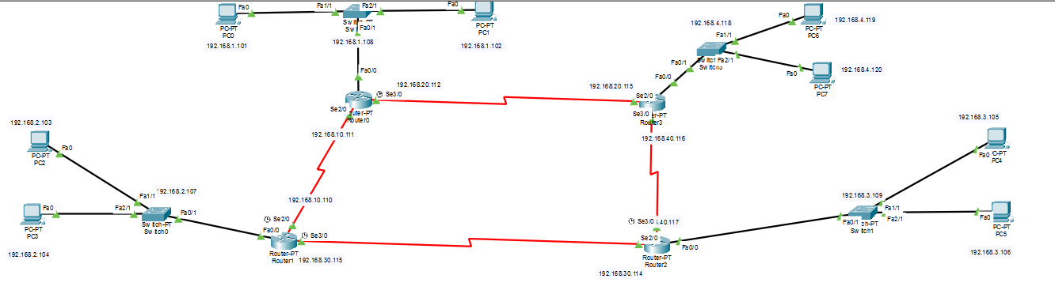
Applying RIP to All Router
Router 1
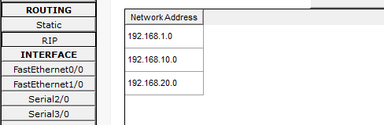
Router 2
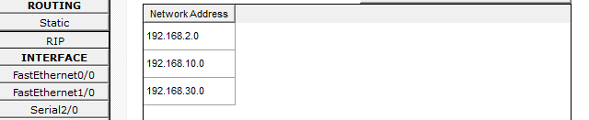
Router 3
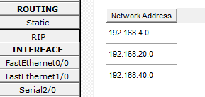
Router 4
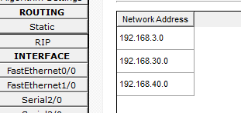
Sending Messages Through to Ping
From PC1(Router 4)
To PC5(Router 3)
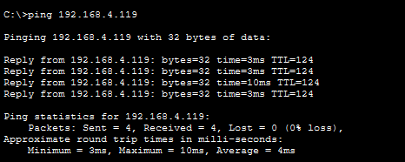
From PC1(Router 3)
To PC2(Router 1)
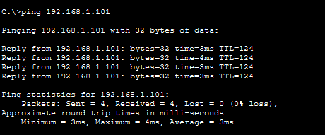
From PC2(Router 2)
To PC1(Router 4)

From PC1(Router 1)
To PC5(Router 4)

Question # 02
Network
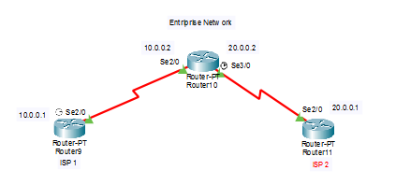
Assigning IP address
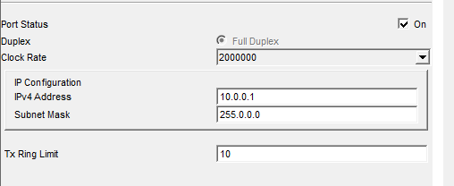
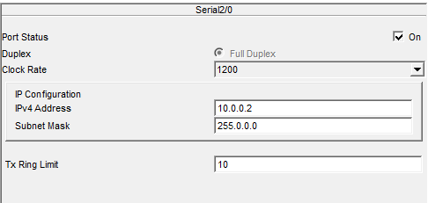
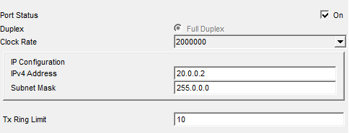
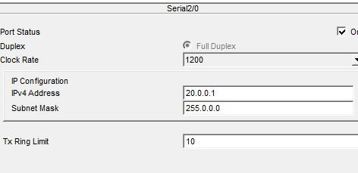
Giving BGP 300 to Entriprise:

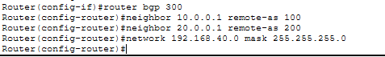
Giving BGP 100 to ISP1:
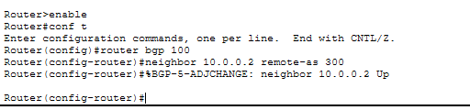
Giving BGP 200 to ISP2:
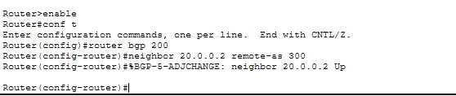

Summary Through Command:
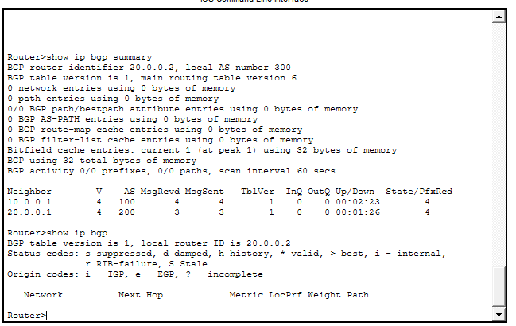

Testing:

